Homework 7: Misorientations
A.D. Rollett, 27-750, Texture, Microstructure and Anisotropy

Due date: 26th March, 2016

Q1. [10 points]
Starting with a set of Miller indices (3 1 -1) [1 0 3], compute the equivalent i) Euler angles in degrees, ii) unit quaternion, iii) angle and axis, iv) Rodrigues-Frank vector and v) orientation matrix

Q1, answer.
Used SteveSintay_Pole_Figures-27Nov11.xls

i) Euler angles (degrees) = 84.3, 107.5, 71.6°

unit quaternion result, q0 q1 q2 q3:
ii) 0.8017, 0.08919, 0.5779, 0.1237
iii) angle, axis: 165.78°, 0.807, 0.090, 0.582

iv) Rodrigues result: 6.479, 0.72076, 4.6697

v) Matrix: 0.316227766, 0.286038777, 0.904534034
Matrix: 0, -0.9535, 0.3015
Matrix: 0.9487, -0.09534, -0.3015

Q2. [50 points]
(a) You are given a list of orientations and your task is to calculate the misorientations between them. Apply the algorithm that applies crystal symmetry to both sides of the misorientation and chooses the smallest possible magnitude of misorientation i.e. smallest rotation angle. Also select the result that places the misorientation axis in the same unit triangle as the list of CSLs that use in part b) below. If you use the list provided in the lecture notes, that means {h>=0, k>=0, l>=0, h>=k>, k>=l}. You may use any method that is convenient to you. Matrices are acceptable, unit quaternions will teach you something new and Rodrigues vectors are inadvisable (because any 180° operator results in infinities). Remember also to include switching symmetry in addition to the crystal symmetry operators. You must calculate both the magnitude of the misorientation and the rotation axis. Also give the values of the Rodrigues vectors that correspond to each axis-angle set.
(b) Also compute how near each misorientation is to each CSL type up to Σ=29 and record how near it is in terms of the Brandon criterion. Remember that the angle that you quote for the “nearness” must be the minimum misorientation angle, which is what we generally take as the physically most meaningful quantity. Remember that it is important to have the misorientation axis (that is associated with the minimum angle misorientation) in the same unit triangle as the CSL. Finally, each of these texture components has 1, 2 or 4 variants, based on the orthorhombic sample symmetry. You must calculate the misorientations between each possible pair of component+variant because each variant is a physically distinct orientation related via sample symmetry (try sketching pole figures for the variants to convince yourself about this, if it is not immediately obvious). This means that you will have to generate the set of Euler angles (or whichever representation that you use) for the variants before you compute the misorientations. Recall that you computed equivalent descriptions of orientations when you worked with pole figures including both crystal and sample symmetry. You must include a copy of your Matlab code with your submission to show how you performed the calculation.

No. | Name | Indices | Bunge  (₁,,₂)  RD= 1 | Number of Variants (sample symmetry)
1 | Copper | {112}↑111 | 90.0, 35.2644, 45.0 | 2
2 | S3 | {213}↑$\bar{3}$$\bar{6}$4 | 59, 37, 63 | 4
3 | Brass | {110}<112> | 35.2644, 45.0, 0.0 | 2

To aid you in confirming that your calculations are coming out correctly, the table below lists the misorientation angles (to two significant figures) that can arise between each combination of components.

 | Copper | S3 | Brass
Copper | 0, 60° | 19°, 51° | 36°
S3 |  | [you tell me!] | 19°, 54°
Brass |  |  | 0°, 60°

Your final submission should look like this. Note that each entry has only one angle and axis, so be sure to sort your answers properly. If the misorientation angle is zero (i.e. no grain boundary) then the axis is irrelevant, obviously, and no entry is needed. Note that a number of the entries are repeats of each other. Because of switching symmetry, only the upper right triangle (or lower left) need be filled in.

Table of Misorientation Angles and Axes

 | Euler angles | Copper, 1st | Copper, 2nd | Brass, 1st | Brass, 2nd | S3, 1st | S3, 2nd | S3, 3rd | S3, 4th
Copper, 1st variant |  | 0 | 60°,  <111>  {1/3,1/3,1/3}
Copper, 2nd variant |  |  | 0
Brass, 1st variant |  |  |  | 0
Brass, 2nd variant |  |  |  |  | 0
S3, 1st variant |  |  |  |  |  | 0
S3, 2nd variant |  |  |  |  |  |  | 0
S3, 3rd variant |  |  |  |  |  |  |  | 0
S3, 4th variant |  |  |  |  |  |  |  |  | 0

Q2. Problem Solving Procedure
The kernel of this problem is to calculate the smallest misorientation between 2 orientations (given certain Euler angles). The misorientation needs to be represented as the magnitude (degree) and the rotation axis. Conventionally, special boundaries (CSL type) are represented as angle-axis pairs, which can be treated as grain (mis-)orientations effectively.
Step1.
Note that your Euler angles may be different in each line depending on what indices you happened to use to obtain the angles. Nonetheless, this should only permute the order of the answers but not the values that you obtain.
Find Euler angles for variants of different texture components applying both crystal and sample symmetry (remember that this was in Homework4). The following table is based on the code mill2eul.f (from neon.materials.cmu.edu/Rollett/texture_subroutines).

($φ_{1}{Φφ}_{2}$) | First Variant | Second Variant | Third Variant | Fourth Variant
Copper | 39.23, 65.91, 26.57 | 90.00,35.26,45.00
S3 | 58.98,36.70,63.43 | 52.87,74.50,33.69 | 121.02,36.70,26.57 | 27.03,57.69,18.43
Brass | 35.26,45.00,0.00 | 54.74,90.00,45.00
Alternatively, note that only sample symmetry was used to obtain these Euler angles of variants, so each listing is a physically distinct orientation, albeit related by sample symmetry.
($φ_{1}{Φφ}_{2}$) | First Variant | Second Variant | Third Variant | Fourth Variant
Copper | 90.00,35.26,45.00 | 270.00, 35.26, 45.00
S3 | 301.02,36.70 26.57 | 238.98, 143.30, 206.57 | 58.98, 143.30, 206.57 | 121.02, 36.70 26.57
Brass | 54.74,90.00,45.00 | 125.26 90.00 225.00

Step2.
Calculate the misorientation between all possible combinations of those variants using the following formula:$Δg=g_{B}⋅g_{A}^{−1}$. The 24 crystal symmetry operators need to be applied to find the smallest misorientation angle. Switching symmetry should be included ($Δg=g_{A}⋅g_{B}^{−1}$). The magnitude of the misorientation angle is given by${\text{cos}}^{−1}(0\text{.}5∗(\text{trace}(Δg)−1))$. The axis can be calculated using the previous code for Homework1, which converts a matrix to an angle-axis pair. Remember that the Rodrigues vector can be calculated based on angle-axis pair as we did in Homework 1.
Step3.
The mis-misorientation between the misorientation between any 2 texture components and a special boundary orientation can be calculated. Then compare the mis-misorientation angle with the minimum tolerance from Brandon criterion ($\text{15}×\frac{1}{\sqrt{{\text{CSL}}_{\text{number}}}}$).
Answers to the questions
Part I
Table of Misorientation Angles and Axes

 | C1 | C2 | B1 | B2 | S3-1 | S3-2 | S3-3 | S3-4
C1 | 0 | 60.00  <111>  {0.33,  0.33,  0.33} | 35.64  <0.05,  0.70,  0.93>  {0.015,  0.19,  0.26} | 35.64  <0.05,  0.70,  0.93>  {0.015,  0.19,  0.26} | 51.51  <0.48,  0.89,  1.19>  {0.15,  0.28,  0.37} | 19.38  <0.23,  0.40,  0.47>  {0.06,  0.10,  0.12} | 51.51  <0.48,  0.89,  1.19>  {0.15,  0.28,  0.37} | 19.38  <0.23,  0.40,  0.47>  {0.06,  0.10,  0.12}
C2 |  | 0 | 35.64  <0.05,  0.70,  0.93>  {0.015,  0.19,  0.26} | 35.64  <0.05,  0.70,  0.93>  {0.015,  0.19,  0.26} | 19.38  <0.23,  0.40,  0.47>  {0.06,  0.10,  0.12} | 51.51  <0.48,  0.89,  1.19>  {0.15,  0.28,  0.37} | 51.51  <0.48,  0.89,  1.19>  {0.15,0.280.37} | 19.38  <0.23,  0.40,  0.47>  {0.06,0.10,0.12}
B1 |  |  | 0 | 60.00  <111>  {0.33,  0.33,  0.33} | 19.41  <0.29,0.39,0.45>  {0.06,0.10,0.12} | 53.67  <0.19,0.996,1.25> {0.06,0.313,0.393} | 53.67  <0.19,0.996,1.25> {0.06,0.313,0.393} | 19.41  <0.29,  0.39,0.45>  {0.06,0.10,0.12}
B2 |  |  |  | 0 | 53.67  <0.19,0.996,1.25> {0.06,0.313,0.393} | 19.41  <0.29,0.39,0.45>  {0.07,0.10,0.12} | 19.41  <0.29,0.39,0.45>  {0.07,0.10,0.12} | 53.67  <0.19,0.996,1.25> {0.06,0.313,0.393}
S3-1 |  |  |  |  | 0 | 50.25  <0.656,0.983,0.983>{0.20,0.30,0.30} | 38.6531  <0.46,0.82,0.82>  {0.13,0.23,0.23} | 38.21  <0.714,0.714,0.714>  {0.20,0.20,0.20}
S3-2 |  |  |  |  |  | 0 | 38.21  <0.714,0.714,0.714>  {0.20,0.20,0.20} | 38.6531  <0.46,0.82,0.82>  {0.13,0.23,0.23}
S3-3 |  |  |  |  |  |  | 0 | 50.25  <0.656,0.983,0.983>{0.20,0.30,0.30}
S3-4 |  |  |  |  |  |  |  | 0

Note: Only the upper right part is tabulated. The lower left triangle must have mirror symmetry along the diagonal.
Part II

There are 8 different misorientations between these texture components and their variants.
Therefore, these 8 misorientations are compared with CSL boundaries to see how near they are in terms of the Brandon criterion. From the tables below, we can see that ∑ 3 is close to the misorientation between copper and its variant, Brass and its variant, and ∑ 7 is close to the misorientation between S3 and its 4th variant, S3’s 2nd and 3rd variants. These values are highlighted in green. The other smallest values are highlighted in yellow.

Table of Angles between the Misorientations and the CSL boundaries

∑ | θ_{m} | Mis.  60.00º | Mis.  35.64º | Mis.  51.51º | Mis.  19.4º | Mis.  53.67º | Mis.  50.25 º | Mis.  38.65º | Mis.  38.21º
3 | 8.7 | 0.00 | 35.76 | 19.72 | 41.10 | 28.34 | 13.91 | 24.35 | 22.03
5 | 6.7 | 48.36 | 23.02 | 33.23 | 27.84 | 33.83 | 38.49 | 31.09 | 34.31
7 | 5.7 | 22.25 | 21.65 | 19.93 | 20.00 | 27.42 | 14.90 | 10.23 | 0.00
9 | 5 | 35.3 | 5.75 | 19.25 | 22.90 | 16.15 | 21.81 | 13.89 | 22.81
11 | 4.5 | 33.62 | 16.33 | 17.01 | 34.19 | 9.09 | 21.48 | 20.13 | 28.91
13a | 4.2 | 50.03 | 21.82 | 37.01 | 16.69 | 8.50 | 39.42 | 28.88 | 30.84
13b | 4.2 | 31.98 | 19.33 | 26.40 | 8.80 | 31.93 | 23.08 | 12.91 | 9.84
15 | 3.9 | 36.79 | 14.43 | 17.49 | 32.51 | 12.80 | 25.45 | 22.43 | 29.85
17a | 3.6 | 48.93 | 21.18 | 34.92 | 20.55 | 36.11 | 38.46 | 28.94 | 31.48
17b | 3.6 | 15.84 | 29.97 | 12.34 | 42.59 | 15.55 | 12.48 | 23.10 | 26.84
19a | 3.4 | 41.16 | 10.72 | 28.09 | 12.76 | 28.02 | 28.65 | 17.21 | 22.59
19b | 3.4 | 13.24 | 25.61 | 16.22 | 27.8 | 25.34 | 8.90 | 12.82 | 8.48
21a | 3.3 | 38.24 | 21.14 | 31.65 | 4.37 | 36.12 | 29.06 | 18.25 | 16.46
21b | 3.3 | 23.08 | 18.26 | 11.86 | 25.86 | 19.51 | 14.74 | 13.48 | 15.03
23 | 3.1 | 31.37 | 16.12 | 17.77 | 23.86 | 22.16 | 22.18 | 17.35 | 20.01
25a | 3 | 52.11 | 24.48 | 40.38 | 14.41 | 42.13 | 41.58 | 30.34 | 31.57
25b | 3 | 22.07 | 18.79 | 7.89 | 33.03 | 8.28 | 10.40 | 14.45 | 21.34
27a | 2.9 | 38.33 | 6.43 | 24.00 | 16.53 | 22.98 | 25.26 | 14.61 | 21.80
27b | 2.9 | 38.83 | 5.67 | 21.78 | 20.46 | 20.70 | 26.38 | 17.65 | 24.29
29a | 2.8 | 48.76 | 26.02 | 3.17 | 33.64 | 33.26 | 39.58 | 33.92 | 37.48
29b | 2.8 | 19.51 | 16.80 | 8.15 | 27.28 | 13.85 | 6.05 | 7.89 | 14.01

Note: The precision is dependent on the programming algorithm used. For the 2nd misorientation, for example, sigma-9 and sigma-27 are very close. For the 5th misorientation, sigma-13a is almost as close as 29b.

Q3. [15 points] The maximum misorientation angle that is possible between two cubic crystals has been given (in L12). (a) Explain how the value is obtained (hint: refer to Rodrigues space) in relation to crystal symmetry elements. (b) Now repeat the calculation for hexagonal crystals and determine the maximum possible misorientation between, e.g., a pair of zirconium crystals.

Q3, answer (a) The explanation for the maximum misorientation angle involves identifying the intersection of the 120°(111) triad symmetry, the 90°(100) 4-fold symmetry and the 180°(110) symmetry elements.
(b) The fundamental zone in the hexagonal system is a 30° sector of 12-sided prism bounded by R3=0 on its base. The plane perpendicular to the c-axis lies at 30°/2=15° from the origin, or R3 = tan(15°) = 0.268. The point farthest from the origin lies at R1=90°=tan45°=1, and R2= tan(15°) = 0.268. Thus the maximum angle = 2. * tan⁻¹(√[1 + 0.268² + 0.268²]) = 2. * tan⁻¹(1.0694) = 93.913°. Diagrams are available in the textbooks.

Q4. [10 points] The shape of the FZ for orientations of hexagonal materials is a 12-sided prism, see the diagram 1.5(d) reproduced from the book by Sutton & Balluffi below. Explain in detail which symmetry operator produces each facet on the prism and how to obtain the dimensions indicated.

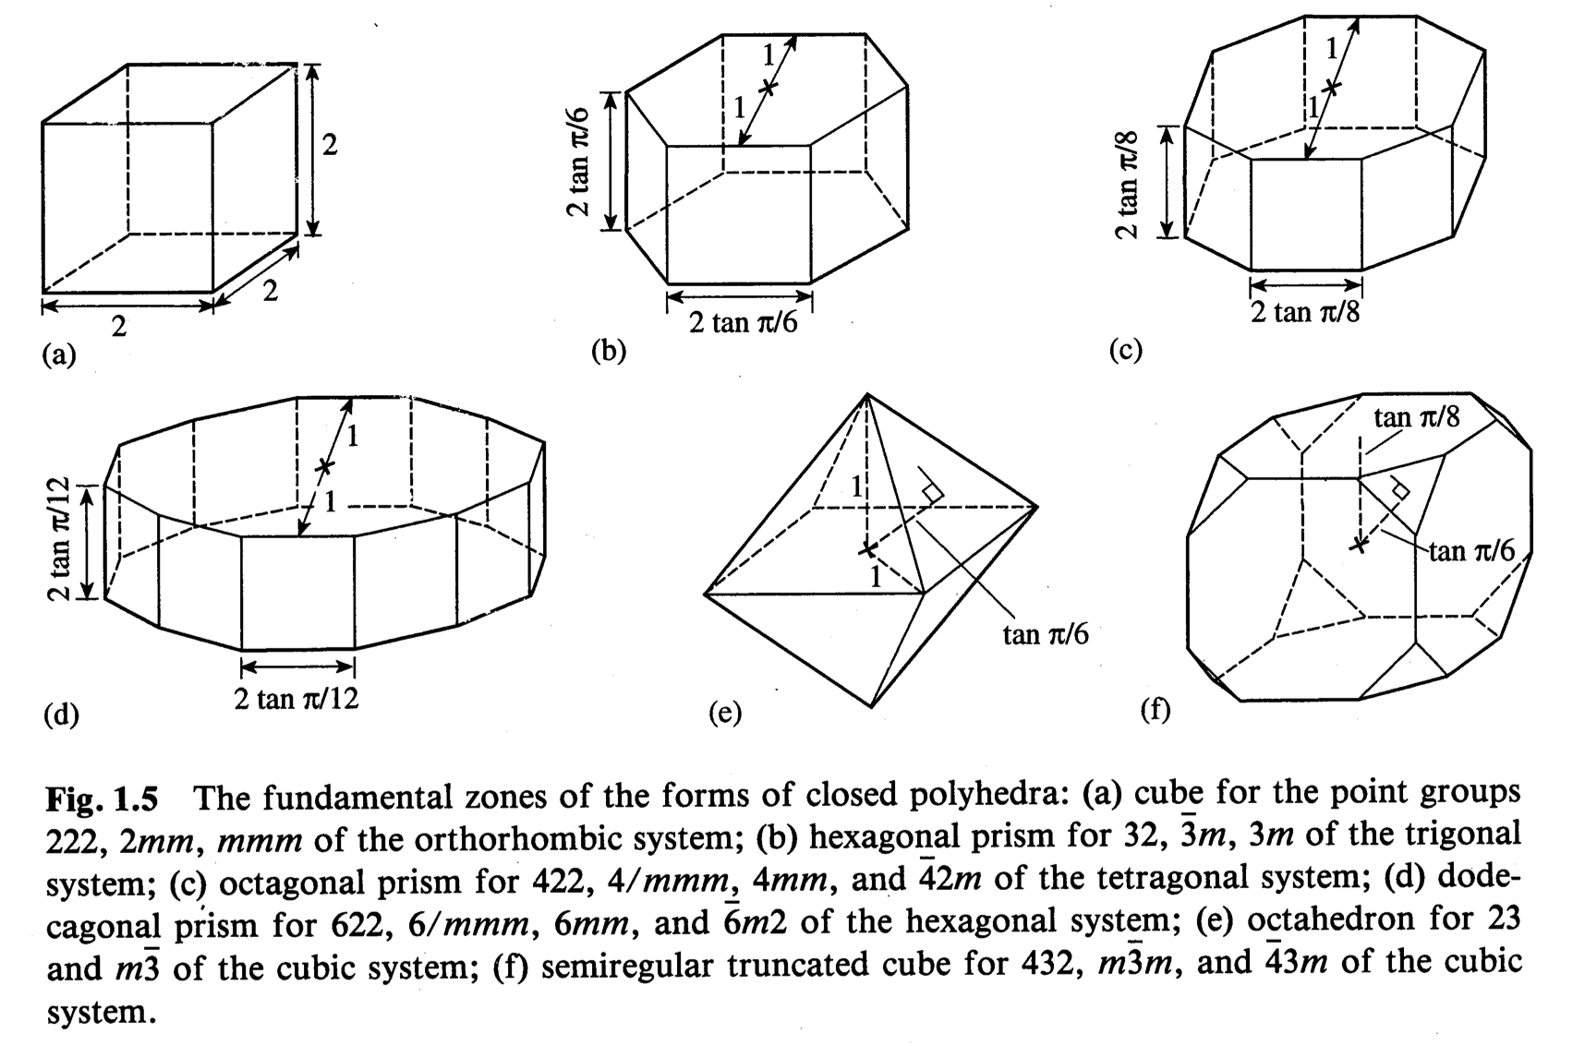

Q4, answer. The top and bottom of the prism are based on the 6-fold symmetry axis aligned with the c-axis; the normal to this plane lies at ¼ of the rotation angle (60°) or 15° from the origin. The bottom of the prism (i.e. perpendicular to R3) is from the same symmetry but with the negative of the angle, hence the total height of 2tan(π/6). The small vertical facets correspond to the 2-fold axes that occur parallel to the -2110 directions (in the basal plane); these facets lie at a perpendicular distance of 1 from the origin because tan(45°)=1, and 45° = 180°/4.

Q5. [15 points]
Make sketches of the Σ9, Σ19a, and Σ11 CSL relationships. Use the construction discussed in the class with two overlapped grids; the grid shown below may be helpful (but think about why it is not square). Label the axes of the grid with the crystallographic directions. Write out the Rodrigues vectors as integer fractions (Hint: the answers are available in the lecture notes but you must show how to obtain the result). Also give the angle in degrees for each of the CSL types. It may help to draw out the Coincident Site Lattice for, say, the Σ9 case and identify the coincident versus the non-coincident points for one of the lattices.

Q5, answer.
\sigma9: The run(m)=√2*2; the rise = 1. RF vector = {1/4,1/4,0}. Therefore the angle = 2*tan⁻¹(1/2√2)=38.9°.
\sigma19a: The run(m)=√2*3; the rise = 1. Therefore the angle = 26.5°. RF vector = tan⁻¹(1/√2*3){1,1,0}
= tan⁻¹(1/√2*3) {1/√2,1/√2,0}={1/6,1/6,0}.
\sigma11: The run(m)=√2*3; the rise = 2. Therefore the angle = 50.47°. RF vector = tan⁻¹(2/√2*3){1/√2,1/√2,0}= {1/3,1/3,0}.

