27-750 Advanced Characterization and Microstructural Analysis

Solution Set as of 12 Feb ‘16

A.D. Rollett: last revised on Feb. 12th, 2016.

Homework 5; multiple topics.

Due: 11:59 p.m., Weds, Feb. 17th.

Question 1. Write an abstract that describes your project for this class. It must address some aspect of texture (which can be orientation texture or interface texture), or anisotropy of material properties (elastic, plastic, electrical, magnetic, photochemical …), or materials characterization (3D techniques are particularly encouraged). The minimum number of words is 300 and the maximum is 500. One figure is the maximum (but not required).

Question 2. Explain in your own words (so do not, e.g., copy from a wiki page) what simulated annealing is. Your description should include the concepts of the *energy landscape*, an *equation* to explain what is done in each step, and some idea of the challenges associated with finding a *global minimum*. The reason for the question is that this technique is commonly used in many areas despite its simplicity and apparent lack of sophistication. In particular, it is an essential component of the HEDM method, in computational thermodynamics (Calphad) and in so-called Monte Carlo grain growth simulation.

Answer. Simulated annealing means the numerical procedure used, for example, to find a minimum in a numerically defined function, for which analytic derivatives are not available. One chooses an initial value of the independent variable and computes the energy. Then a new value is chosen, generally as a small perturbation away from the initial value and a new energy is computed. If that new energy is lower than the previous value, the change is accepted; otherwise the change is rejected. The energy landscape has to do with the shape or morphology of the variation in energy with the independent variable. If this shape is just a simple variation with a single minimum then finding the global minimum is likely to succeed easily. If, as in HEDM, the energy varies very little but every now and again there is a deep “well” then the method have to use a very large number of iterations before it finds the deepest well and one can be confident that the global minimum has been identified. In the case of Calphad, it is often the case that one is dealing with intersecting polynomial functions that have very small gradients, which also makes it difficult to find the true global minimum (Gibbs free) energy.

Question 3.

a) Use Matlab to construct your own Hough transform of the figure shown below (also available as a JPG on Box). The expected result, obviously, is that you will obtain the same set of three butterfly pattern described in the notes. To accomplish this will require following the procedure shown in the link below rather carefully. Hint: I had to expand the angle axis in the recommended plot in order to obtain a reasonable aspect ratio (presumably because the image is large in pixels).

<http://www.mathworks.com/help/images/ref/hough.html>

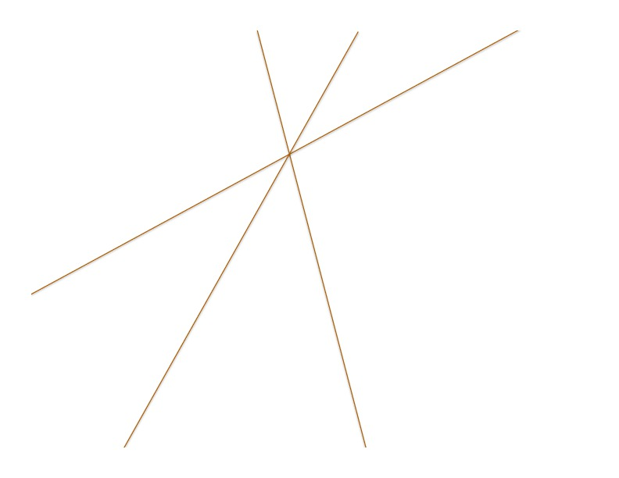

The expected result is as follows:



b) Read the paper by Hart provided (also on Box) and report on what equation is used to transfer intensity from each point in a measured (or synthesized) image to the accumulator diagram in the Hough transform.

Equation (1) defines the development of a line in Hough space from a point in the image.



c) Show how to read off the angles between the lines from the Hough transform.

It should be fairly obvious that one drops vertical lines from the center of each butterfly down to the angle axis and reads off the differences in angular position.