Homework 3; due Saturday 8th Feb. ‘20

27-731

Jerard V. Gordon & A.D. Rollett

100 points

**Tensors, Rotations, Transformations, Anisotropic Elasticity**

1. *Sample* to *crystal* axis transformations are very important in the context of texture and anisotropy. Being able to change from one to the other is therefore very important, particularly when dealing with tensors.

a) [5 points]. Calculate the transformation matrix αij from *sample* to *crystal* axes for the “cube orientation” with Euler angles (φ1,Φ,φ2) = (0°, 0°, 0°). How do the components of αij make physical sense?

*Recall from lecture: αij = A = Z2XZ1, where:*

*; ;*

*Therefore,*

$${}_{ij} = \left(\begin{matrix}1 & 0 & 0 \\ 0 & 1 & 0 \\ 0 & 0 & 1\end{matrix}\right)$$

*The components of the transformation matrix make physical sense in that component sample and crystal axes are aligned for a cube orientation. Therefore, the leading diagonals should be ones, and the off diagonal terms equal to zero.*

b) [5 points] Calculate a transformation matrix from a set of Miller indices (hkl)[uvw] = (001)[100]

*From the lecture notes,*

$${}_{ij} = \left(\begin{matrix}b_{1} & t_{1} & n_{1} \\ b_{2} & t_{2} & n_{2} \\ b_{3} & t_{3} & n_{3}\end{matrix}\right)$$

*Where:*

$\hat{n}=\frac{\left(h,k,l\right)}{\sqrt{h^{2}+k^{2}+l^{2}}}$; $\hat{b}=\frac{\left(u,v,w\right)}{\sqrt{u^{2}+v^{2}+w^{2}}}$; $\hat{t}=\frac{\hat{n} ×\hat{ b}}{\left|\hat{n} ×\hat{ b}\right|}$

*In component form:*

$n_{1}=\frac{h}{\sqrt{h^{2}+k^{2}+l^{2}}}=0$; $n_{2}=\frac{k}{\sqrt{h^{2}+k^{2}+l^{2}}}=0$; $n_{3}=\frac{l}{\sqrt{h^{2}+k^{2}+l^{2}}}=1$

$b_{1}=\frac{u}{\sqrt{u^{2}+v^{2}+k^{2}}}=1$; $b_{2}=\frac{v}{\sqrt{u^{2}+v^{2}+k^{2}}}=0$; $b_{3}=\frac{u}{\sqrt{u^{2}+v^{2}+k^{2}}}=0$

$t_{1}=\frac{\hat{n} ×\hat{ b}}{\left|\hat{n} ×\hat{ b}\right|}=\frac{n_{2}b_{3}-n_{3}b_{2}}{\left|\hat{n} ×\hat{ b}\right|}=$; $t_{2}=\frac{n_{3}b_{1}-n_{1}b_{3}}{\left|\hat{n} ×\hat{ b}\right|}=1$; $t_{3}=\frac{n_{1}b_{2}-n_{2}b_{1}}{\left|\hat{n} ×\hat{ b}\right|}=0$

*Thus:*

$${}_{ij} = \left(\begin{matrix}1 & 0 & 0 \\ 0 & 1 & 0 \\ 0 & 0 & 1\end{matrix}\right)$$

c) [5 points] Are your answers in parts a) and b) equivalent? Why or why not?

*These answers are equivalent because the “cube orientation” can be written as either Euler angles(0°, 0°, 0°) or Miller indices (001)[100].*

2. Tensors are defined as a quantity that obeys certain have transformation “rules”. For example, a second ranked tensor Tij transforms as: T’ij = αimαjnTmn. However, in general, we prefer to use “short hand” matrix notation of the form: **T’**= **αTαT** (note **BOLD** refers to a matrix).

a) [10 points] Show the general expression for T’ijfor an arbitrary rotation θ about the [001] axis e.g. [θ@ [001]).

$${T'}_{ij}={}_{im}{}_{jn}T_{mn}=T{}^{T}=$$

$$\left(\begin{matrix}cos+u^{2}(1-cos) & uv\left(1-cos\right)+wsin & uw\left(1-cos\right)-vsin \\ uv\left(1-cos\right)-wsin & cos+v^{2}(1-cos) & vw\left(1-cos\right)+usin \\ uw\left(1-cos\right)+vsin & vw\left(1-cos\right)-usin & cos+w^{2}(1-cos)\end{matrix}\right)\left(\begin{matrix}T_{11} & T_{12} & T_{13} \\ T_{21} & T_{22} & T_{23} \\ T_{31} & T_{32} & T_{33}\end{matrix}\right)\left(\begin{matrix}cos+u^{2}(1-cos) & uv\left(1-cos\right)-wsin & uw\left(1-cos\right)+vsin \\ uv\left(1-cos\right)+wsin & cos+v^{2}(1-cos) & vw\left(1-cos\right)-usin \\ uw\left(1-cos\right)-vsin & vw\left(1-cos\right)+usin & cos+w^{2}(1-cos)\end{matrix}\right)$$

$$=\left(\begin{matrix}cos & sin & 0 \\ -sin & cos & 0 \\ 0 & 0 & 1)\end{matrix}\right)\left(\begin{matrix}T_{11} & T_{12} & T_{13} \\ T_{21} & T_{22} & T_{23} \\ T_{31} & T_{32} & T_{33}\end{matrix}\right)\left(\begin{matrix}cos & -sin & 0 \\ sin & cos & 0 \\ 0 & 0 & 1\end{matrix}\right)$$

*For α (or gij in lecture notes):*

$${}_{ij}==\left(\begin{matrix}cos+u^{2}(1-cos) & uv\left(1-cos\right)+wsin & uw\left(1-cos\right)-vsin \\ uv\left(1-cos\right)-wsin & cos+v^{2}(1-cos) & vw\left(1-cos\right)+usin \\ uw\left(1-cos\right)+vsin & vw\left(1-cos\right)-usin & cos+w^{2}(1-cos)\end{matrix}\right)$$

b) [5 points] For a θ=180-degree rotation about [001], what is **T’**? How does it compare to **T**? How do the components of our α matrix make physical sense in describing the rotation?

$${T'}_{ij}=\left(\begin{matrix}-1 & 0 & 0 \\ 0 & -1 & 0 \\ 0 & 0 & 1)\end{matrix}\right)\left(\begin{matrix}T_{11} & T_{12} & T_{13} \\ T_{21} & T_{22} & T_{23} \\ T_{31} & T_{32} & T_{33}\end{matrix}\right)\left(\begin{matrix}-1 & 0 & 0 \\ 0 & -1 & 0 \\ 0 & 0 & 1\end{matrix}\right)=\left(\begin{matrix}T_{11} & T_{12} & {-T}_{13} \\ T_{21} & T_{22} & -T_{23} \\ {-T}_{31} & -T_{32} & T_{33}\end{matrix}\right){=T}_{ij}$$

***T'*** *is equivalent to* ***T*** *due to our tensor transformation rules. The transformation matrix α makes physical sense because we are “fixing” the z-axis of α (e.g. α33=1) and rotating our basis vectors “x” and “y” to their negative values (e.g. -1 because of the 180-degree rotation). Where we see that a component of T’ is equal to its negative in T, the only value that satisfies the relation is zero. Therefore T31 = T32 = T23 = T13 = 0. Hence we see how applying symmetry decreases the number of independent components in a second rank tensor. In fact, cubic symmetry means that any 2nd rank tensor property must be isotropic, i.e., all off-diagonal components are zero and the leading diagonal components are equal to each other.*

3. The Youngs Modulus Ehkl of a specific crystallographic plane (hkl) is given by:

$$\frac{1}{E_{hkl}}=S_{11}-2\left[\left(S_{11}-S_{12}\right)-\frac{1}{2}S_{44}\right]\left(α^{2}β^{2}+α^{2}γ^{2}+β^{2}γ^{2}\right)$$

Where Sij are components of the compliance tensor and α, β, and γ are the direction cosines of the principle directions in a cubic lattice. Direction cosines are given as follows: α = the cosine of the angle between (hkl) and [100]; β = the cosine of the angle between (hkl) and [010]; and γ is the cosine of the angle between (hkl) and [001].

a) [10 points] Which direction E111, E100, or E110 is the stiffest for an Fe-alloy where: S11 = 9.88 x 10-12 Pa-1 , S12= -3.77 x 10-12Pa-1, and S44 = 7.22 x 10-12Pa-2?

**Hint**: A direction cosine can also be written as: $\frac{\left(hkl\right)∙[uvw]}{\left|\left(hkl\right)\right|∙\left|[uvw]\right|}$

**For (hkl)= (111)**

$=\frac{\left(111\right)∙[100]}{\left|\left(111\right)\right|∙\left|[100]\right|}=\frac{1}{\sqrt{3}}$

$=\frac{\left(111\right)∙[010]}{\left|\left(111\right)\right|∙\left|[010]\right|}=\frac{1}{\sqrt{3}}$

$\cos{} =\frac{\left(111\right)∙[001]}{\left|\left(111\right)\right|∙\left|[001]\right|}=\frac{1}{\sqrt{3}}$

$$\frac{1}{E_{111}}=9.88-2\left[\left(9.88)-(-3.77\right)-\frac{1}{2}(7.22)\right]\left({3*\left(\frac{1}{\sqrt{3}}\right)}^{2}{\left(\frac{1}{\sqrt{3}}\right)}^{2}\right)$$

$$E_{111}=\frac{1}{\left[9.88-2\left[\left(9.88)-(-3.77\right)-\frac{1}{2}(7.22)\right]\left(0.334\right)\right]}=3.15x{10}^{11}Pa or 315 GPa$$

**For (hkl)= (100)**

$=\frac{\left(100\right)∙[100]}{\left|\left(100\right)\right|∙\left|[100]\right|}=1$

$=\frac{\left(100\right)∙[010]}{\left|\left(100\right)\right|∙\left|[010]\right|}=0$

$\cos{} =\frac{\left(100\right)∙[001]}{\left|\left(100\right)\right|∙\left|[001]\right|}=0$

$$\frac{1}{E_{100}}=9.88-2\left[\left(9.88)-(-3.77\right)-\frac{1}{2}(7.22)\right]\left(0\right)$$

$$E_{100}=\frac{1}{\left[9.88\right]}=1.012x{10}^{11}Pa or 101.2 GPa$$

**For (hkl)= (110)**

$=\frac{\left(110\right)∙[100]}{\left|\left(110\right)\right|∙\left|[100]\right|}=\frac{1}{\sqrt{2}}$

$=\frac{\left(110\right)∙[010]}{\left|\left(110\right)\right|∙\left|[010]\right|}=\frac{1}{\sqrt{2}}$

$\cos{} =\frac{\left(110\right)∙[001]}{\left|\left(110\right)\right|∙\left|[001]\right|}=0$

$$\frac{1}{E_{110}}=9.88-2\left[\left(9.88)-(-3.77\right)-\frac{1}{2}(7.22)\right]\left(0.25\right)$$

$$E_{110}=\frac{1}{9.88-2\left[\left(9.88)-(-3.77\right)-\frac{1}{2}(7.22)\right]\left(0.25\right)}=2.06x{10}^{11}Pa or 206 GPa$$

b) [12 points] Within the (100) plane, show where the maximum Ehkl value(s) occur for an arbitrary vector making an angle with the [100] loading axis between 0 and 90 degrees. Which Ehkl value(s) are the least? Which are the largest Ehkl value(s)?

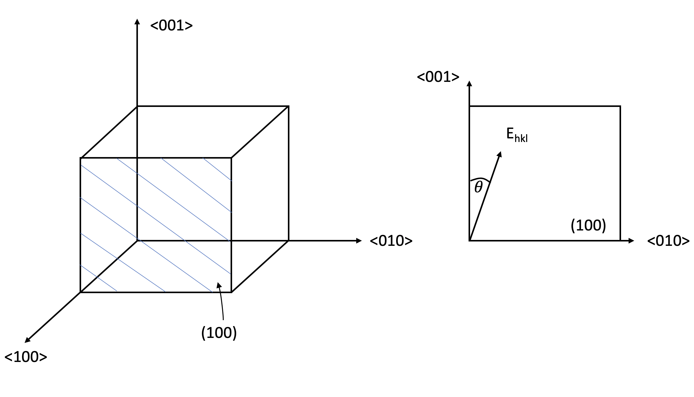

Recall from the lecture notes:

$$\frac{1}{E_{hkl}}=\frac{1}{E_{100}}-3\left[\frac{1}{E_{100}}-\frac{1}{E_{111}}\right]\left(α^{2}β^{2}+α^{2}γ^{2}+β^{2}γ^{2}\right)$$

We can see from the diagram on the left that

$=0$ i.e. the cosine of the angle between Ehkl in the (100) and <100>

$β=\cos\left(90-\right)$ i.e. the cosine of the angle between Ehkl in the (100) and <010>

$γ=cos⁡()$ i.e. the cosine of the angle between Ehkl in the (100) and <001>

So, we can plug in the E100 and E111 values we calculated in (a), as well as $=cos⁡()$ and $β=\cos\left(90-\right)$ into the equation above. We get a graph like:

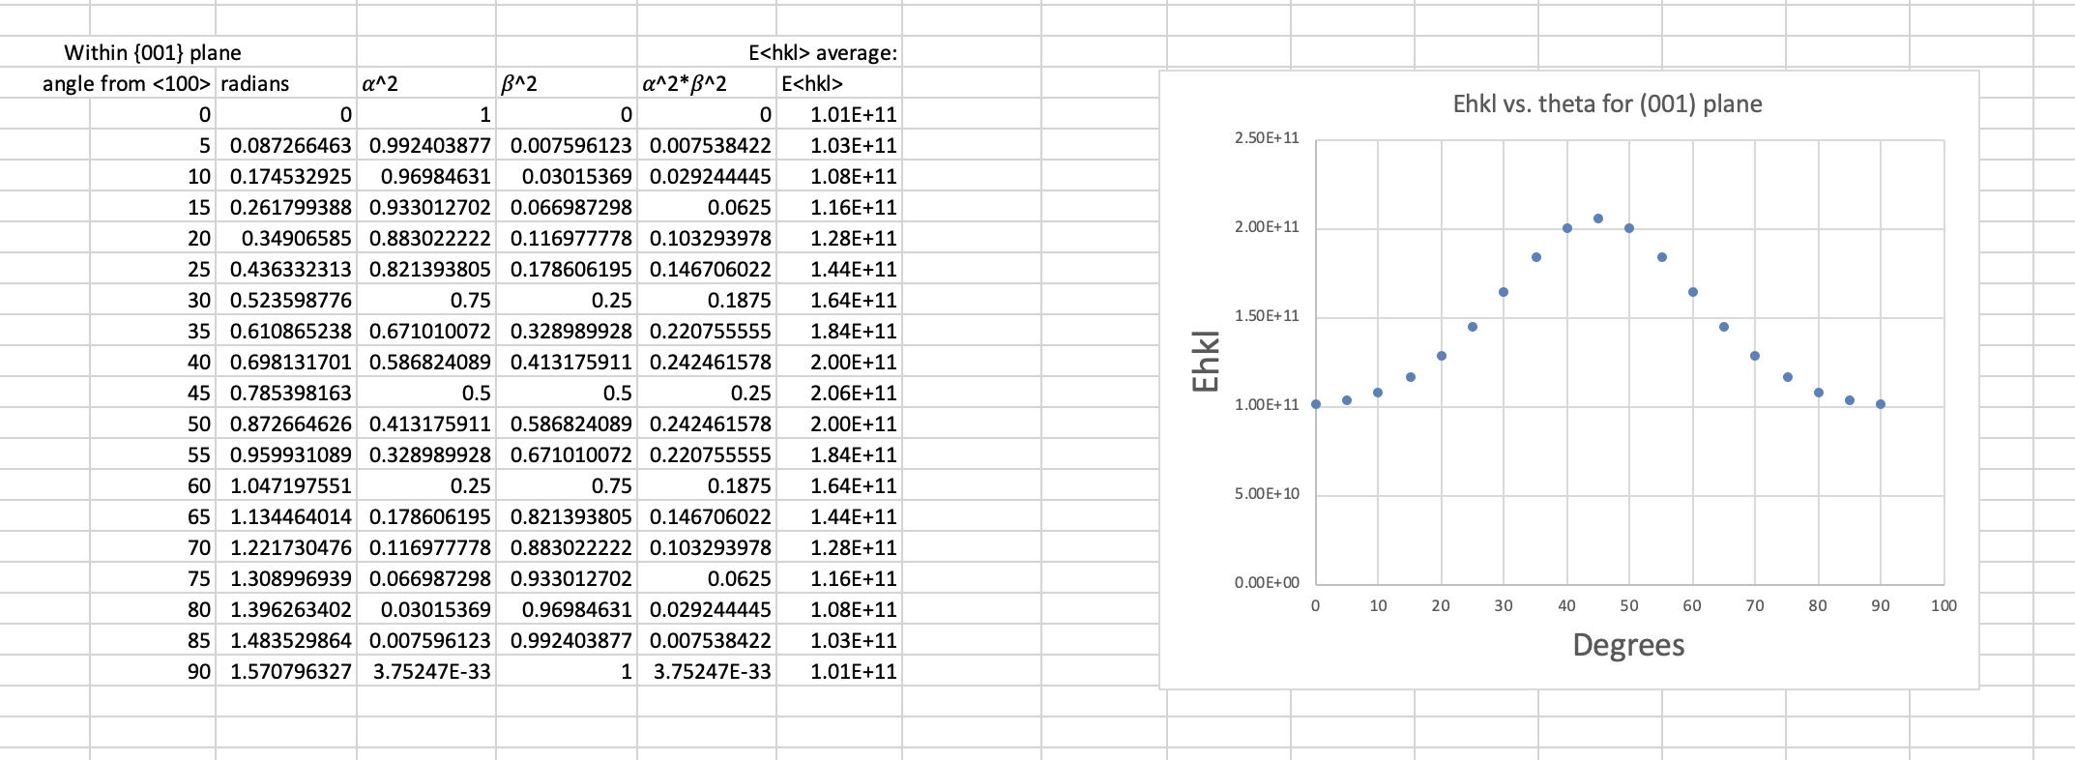

We see that E110 (at 45 degrees) possesses the largest value of 206 GPa and E001= E010=101 GPa (at 0 and 90 degrees) have the smallest moduli.

c) [3 points] Prove this material is either a: (1) *relatively* elastically isotropic, or (2) an anisotropic material.

**Hint**: we can convert C=S-1 via the following relationships:

C11 = (S11+S12)/{(S11-S12)(S11+2S12)} =0.1913  
  
C12 = - S12/{( S11- S12)( S11+2S12)}=0.118  
  
C44 = 1/S44 =0.138

Therefore, this material is definitely anisotropic since A >>1!

4. [25] Plot the composite moduli as a function of volume fraction for a Cu-W material with properties: Ecopper = 120 GPa and ETungsten = 411 GPa for the “Isostress” and “Isostrain” cases. How do experimental results for Cu-W compare to these two bounds?

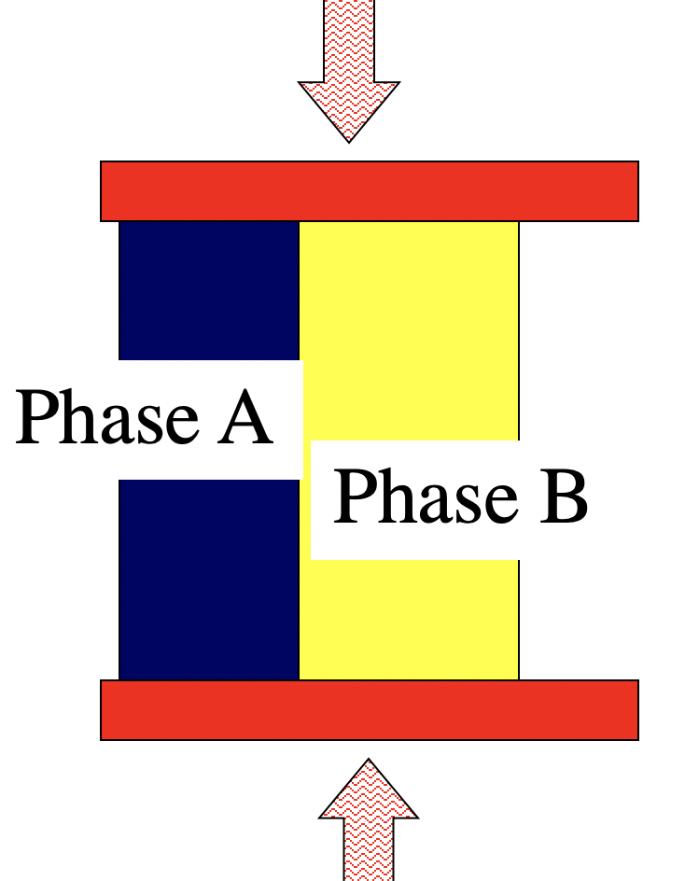 “Isostrain” 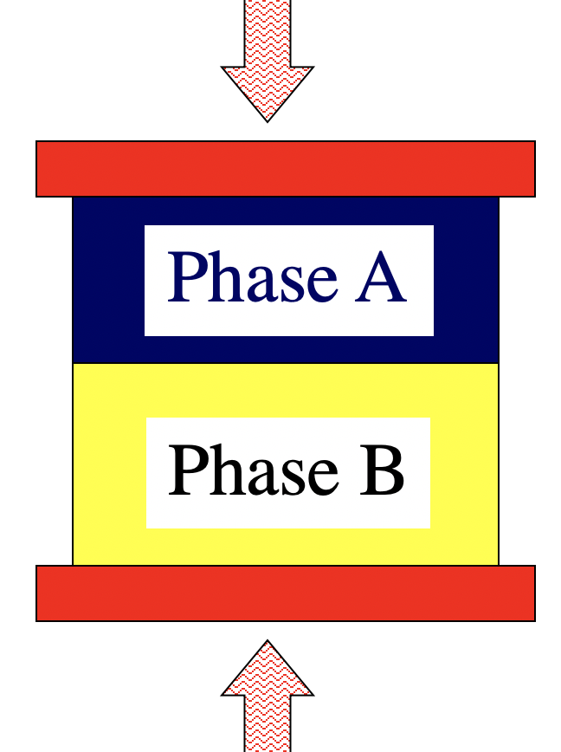 “Isostress”

Hint: recall the equations for composite modulus for Isostress and Isostrain cases:

$$E_{C, Voigt}={V_{f}}^{A}E_{A}+ {V_{f}}^{B}E_{B}$$

$$E_{C,Reuss}=\frac{E_{A}E_{B}}{{V_{f}}^{A}E_{B}+ {V_{f}}^{B}E_{A}}$$

By using the Voigt and Reuss equations, we get a graph similar to the one below:

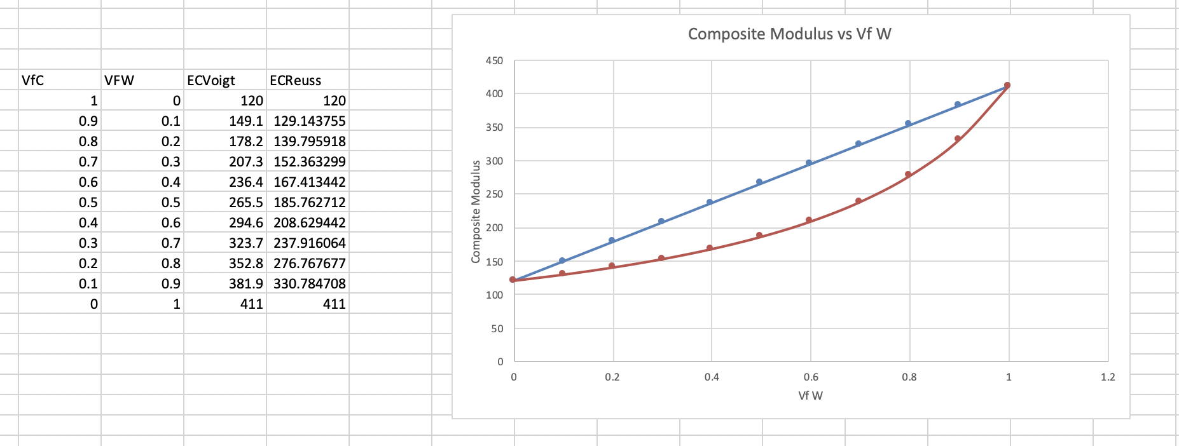

Note: we could have also plotted the composite values vs. the Vf of Cu!

Studies such as: **Wen, S. P., et al. "Evaluating modulus and hardness enhancement in evaporated Cu/W multilayers." Acta materialia 55.1 (2007): 345-351** place the values for composite modulus of Cu-W materials between 143 and 235 GPa for a Vf = 0.5 (for either Cu or W). Therefore, our estimates for composite moduli do a pretty good job!

5. [20] EBSD data acquisition

(a) Describe in your own words how an accumulator diagram is used to apply the Hough transform to an EBSD diffraction image. Describe explicitly with an equation(s) how intensity values are transferred from the original image (diffraction pattern) to the accumulator image (diagram).

The intensity at each point in the original is copied into (added to) a set of cells in the accumulator. The coordinates of the set are found by solving for the variable rho over a range of theta [0..180] with the [xi,yi] coordinates from the ith point in the original.

latex-image-1.pdf

(b) Run the python code provided (*hough-python-v1.py*) and make any adjustments needed to obtain images like the ones below. This code ran on my 2010 Macbook with 10.13 and python3 (installed from python.org).

*image.png* and *accumulator.png*

(c) Modify the code so as to obtain the Hough transform of a band such as one sees in EBSD patterns, i.e., a line of finite width, and,

(d) the Hough transform of two intersecting bands. In both cases, describe what you see. You may find it helpful to look for the blog written by Stuart Wright about EBSD.

The band (as opposed to the line) should yield a wider range of sinusoids that all pass through an enlarged point in the accumulator.

Two bands will yield two sets of sinusoids that intersect at two different points, each of which represents the distance and angle of the “support line” for each band, i.e., a line perpendicular to the band passing through the point of closest approach to the origin.