27-731, A.D. Rollett & J.V. Gordon

Due: Weds., 31st Jan., 2020.

Homework 2. Exercises with random orientations and pole figures [130 points]

Revised 25th Jan., 2020.

1. [25 points]

Construct {100} and {110} pole figures for the Brass component, using the stereographic projection. You can find the expected result by looking back through the lecture notes.

Hints. (a) The points to be projected are on a sphere of unit radius, which ensures that each pole has unit length.

(b) The pole figure to be drawn is a circle of unit radius.

(c) Points on the southern hemisphere project outside the circle and should be ignored.

(d) Make a list of all the equivalent {100} and {110} poles by generating all the equivalent points using crystal symmetry on a single example of each pole. Then apply the (inverse of the) orientation transformation followed by calculation of the projected coordinates in the plane of the pole figure. You should already have the set of symmetry operators from the first homework.

(e) It is good practice to draw lines or arrows to indicate the positions of the x and y sample axes and to draw a circle around the figure (as noted above).

(f) To take account of sample symmetry, it should work to use the program/script that you developed in the last homework in which you applied sample symmetry. You should find that the output of that calculation gives you all the variants of the orientation. Also, if you leave the plot window open, subsequent plots will superimpose on the previous ones.

A. See below

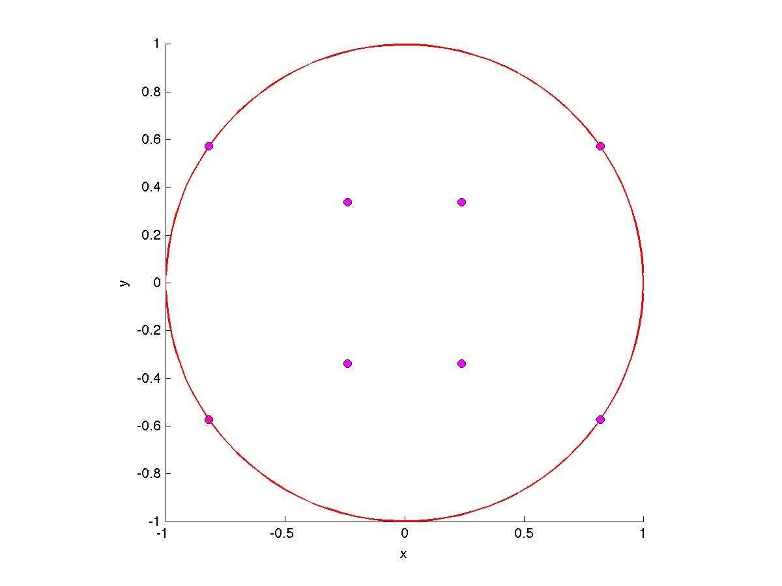

{100}

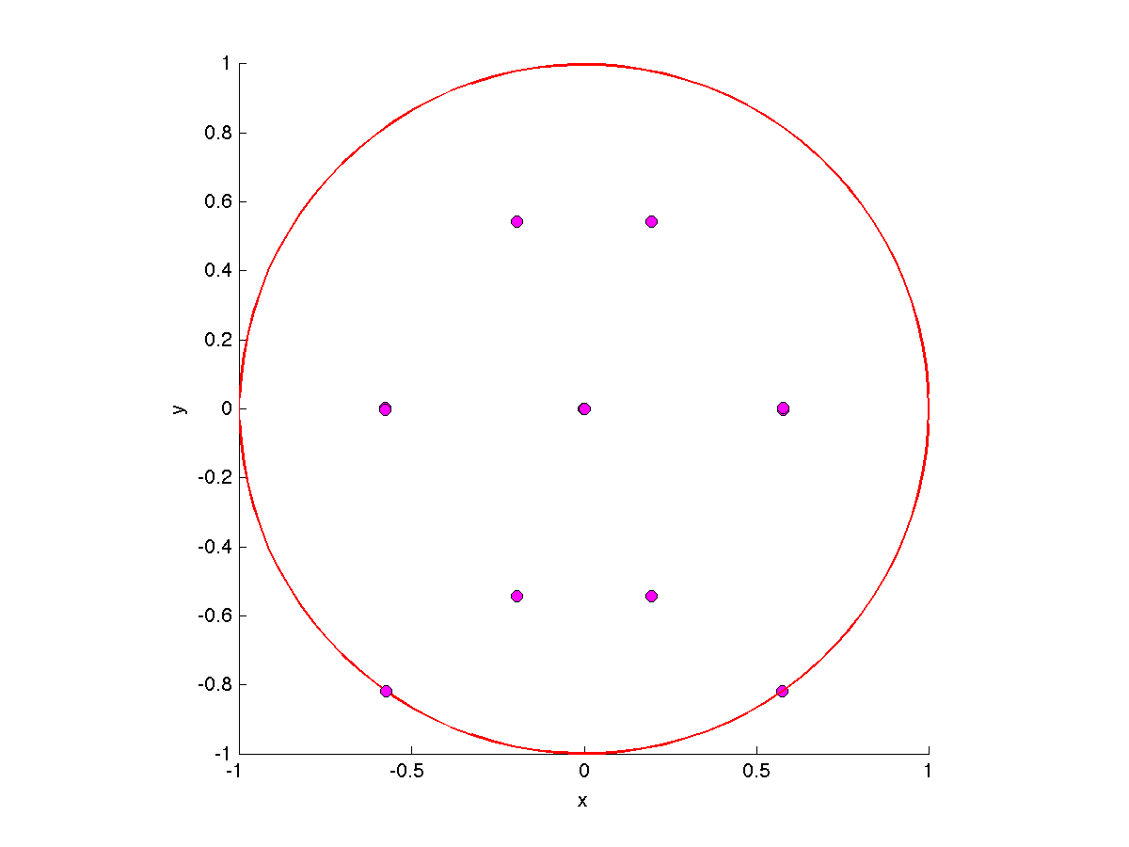

{110}

Note the {110} figure above has a couple of missing poles on the upper edge because of numerical issues.

2. [10] Repeat the above to generate an inverse pole figure for the sample-Z direction (“ND”) for the Brass component.

A. See the lecture notes: there should be points on top of all <110> directions.

3. [25] Generate a set of random orientations and plot them in Euler space. Orient the plot (if 3D) so that you see either the 1st and 2nd angles or the 2nd and 3rd angles. Alternatively, make a 2D plot of the 1st versus the 2nd angle, or the 2nd versus the 3rd angle. Describe the variation in the density of points with respect to each angle.

Hints. Matlab provides a function “rand” that generates sets of random numbers. “x=rand(200)” generates, e.g., a set of 200 random numbers (uniformly distributed over the interval 0 to 1). There is a similar capability in python.

There are many ways to generate random orientations and one method is to generate random values of the Euler angles. For the 1st and 3rd angles, one can simply multiply the randomly generated numbers by the desired range, say 360° (or 2π). However, one must, for the 2nd angle, multiply the random number by 2, subtract 1 (so that it has the range -1 to +1), take the arc-cosine of the result and then (perhaps) multiply it by 180°/π to get degrees). As discussed in class, this is necessary for obtaining a uniform coverage of points on a unit sphere.

If you want to have some fun, try plotting your randomly chosen orientations on the surface of a sphere as, e.g., combinations of f1 and F, or f2 and F. See:  
<https://stackoverflow.com/questions/31768031/plotting-points-on-the-surface-of-a-sphere-in-pythons-matplotlib> .

A. You should observe a gradation in the density of points with respect to the  value, but not the  or  values. The gradation should be such that the density is low towards  and high near .

4. [10] Use the procedure that you developed before to plot a {100} pole figure (or any other pole of your choice) of your random set. Comment on the distribution of points in the stereogram, especially as compared to the Euler space plot. This should help convince you that the procedure above produces a uniform distribution on the sphere. You can try plotting with or without crystal symmetry (but it should not make any difference).

As noted above, packages such as *matplotlib* in python have ways of plotting points on a sphere. For extra credit, see if you can plot your points on a sphere to visualize the near-uniformity of coverage. Then you can instead make a set of random values of two spherical angles (i.e., latitude and longitude) and try plotting them, which should illustrate highly non-uniform coverage.

A. The density of points on the plot should be uniform or nearly so. A subtle variation on this exercise would be to use the Equal Area projection instead of the Stereographic (see the lecture notes), which should produce a more uniform density.

5. [10] Bin the points in 10° cells according to the 2nd angle (), i.e. in intervals 0-10, 10-20, 20-30 … 80-90° (9 bins/cells in all). Plot a histogram (or 2D scatter plot) of the count in each bin versus the mid-point of the bin (5, 15, 25, … 85°).

A. The histogram should trace out the function sin() which is the trigonometric factor in the volume element. This is a step towards quantifying the qualitative observation in Q1.

6. [10] Repeat the plot above but now divide each value by the total number of points, which gives you a volume fraction in each bin. On the same graph, plot the definite integral of sin() for each cell, i.e. cos(0)-cos(10), cos(10)-cos(20), etc. This compares the theoretical volume fraction in each cell with a random sampling.

Hint. The values should be close unless you generated a very small number of random orientations. Note that this approach is effectively cell-edge binning (as opposed to cell-centered).

A. The variation in height of each bin should correspond to the sine function as mentioned in the hint.

7. [10] Convert the values in each bin to intensities and plot them versus the mid-point angle. Hint. The procedure is described in the lecture notes. What line can you draw on the graph that is the theoretically expected value (for a truly random texture)? Hint: it should be a horizontal line.

A. The horizontal line mentioned in the hint corresponds to a uniform intensity equal to one, which is what a randomly chosen set of orientations should produce.

8. [10 total]

[5] (a) What Miller indices are associated with each end of the “alpha fiber” in rolled fcc metals and what range of Euler angles are associated with this fiber? Hint: the charts developed by Bunge of Miller indices of points in Euler space should help you.

A. This lies between Goss ({011}<100>) and Brass ({110}<112>), with Euler angles equal to 0-35° for 1,  = 45° and 2 = 0°.

(b) [5] What Miller indices are associated with the “gamma fiber” in rolled bcc metals and what range of Euler angles are associated with this fiber?

The gamma fiber for rolled bcc metals includes all orientations with <111> parallel to the ND (sample Z); the Euler angles are 1 = {0, 90°}, 2= 45° and  = 54.74°.

9. [5] Explain in your own words (or equations) the difference between the normalization applied to binned frequency data to obtain a probability density function (pdf) versus that applied to orientation distributions (ODFs). In each case, is the value for a uniform (random) distribution = 1?

A. For a pdf, normalize to obtain unit area under the curve; for odfs, normalize to obtain unit average value. For *pdf*, *no* but for an ODF, *yes*.

9. [15] Referring to slide 42 in Orient_Dist-28Jan20.pptx, compute orientation matrices for each of the Copper, Brass and Goss components.

Hint: for the latter two components, you can check your result either from Q1 above or from the lecture notes.

A. Copper:

|  |  |  |
| --- | --- | --- |
| -0.57923 | 0.707107 | 0.40558 |
| -0.57923 | -0.70711 | 0.40558 |
| 0.573576 | 0 | 0.819152 |

Brass:

|  |  |  |
| --- | --- | --- |
| 0.40558 | 0.579228 | 0.707107 |
| -0.40558 | -0.57923 | 0.707107 |
| 0.819152 | -0.57358 | 0 |

Goss:

|  |  |  |
| --- | --- | --- |
| 0 | 0.707107 | 0.707107 |
| 0 | -0.70711 | 0.707107 |
| 1 | 0 | 0 |

.