27-750 Mid-term, take-home;

100 points

Available: 10 a.m. Saturday, 20th

Due: 11:59 p.m. Sunday, 21st

1. [10] In the formulae given in the lecture notes on volume fractions, the quantity 8100°2 is often found in relation to the subset of orientation space that spans 0 to 90° for all three Euler angles. Where does this quantity come from and why are the units degrees squared?

Answer: all one has to do is to integrate the volume element d1d2sind over the range of angles specified. The 1st and 3rd angles integrate to 90° each, giving 8100 degrees square and the third integrates to 1, because that’s the range over which to integrate the sine function.

2. [30]

a) Plot inverse pole figures for the sample X and sample Z directions using Matlab (not MTEX) for the Copper, S and Brass components. Show the Matlab script that you used to generate the plots. You can extract Euler angles from the lecture notes. Apply cubic crystal symmetry and plot a full circle (because limiting the area to a single stereographic triangle is more difficult).

(b) Does it make any difference whether you apply sample symmetry or not?

(c) To clarify what the inverse pole figures show, make a PDF (or whatever format suits you) of your plot from part (a) and use a graphics program (or even just powerpoint) to trim it down to a single standard stereographic triangle; then identify the point that corresponds to each texture component in each plot. If you see anything other than three points in each of the two plots, then something is wrong.

(d) explain how your plots correspond to the (hkl)[uvw] specifications of the three texture components.

Answer:

(a) the inverse pole figures will look busy because each triangle has 3 points (allowing for overlap at edges);

Brass component:

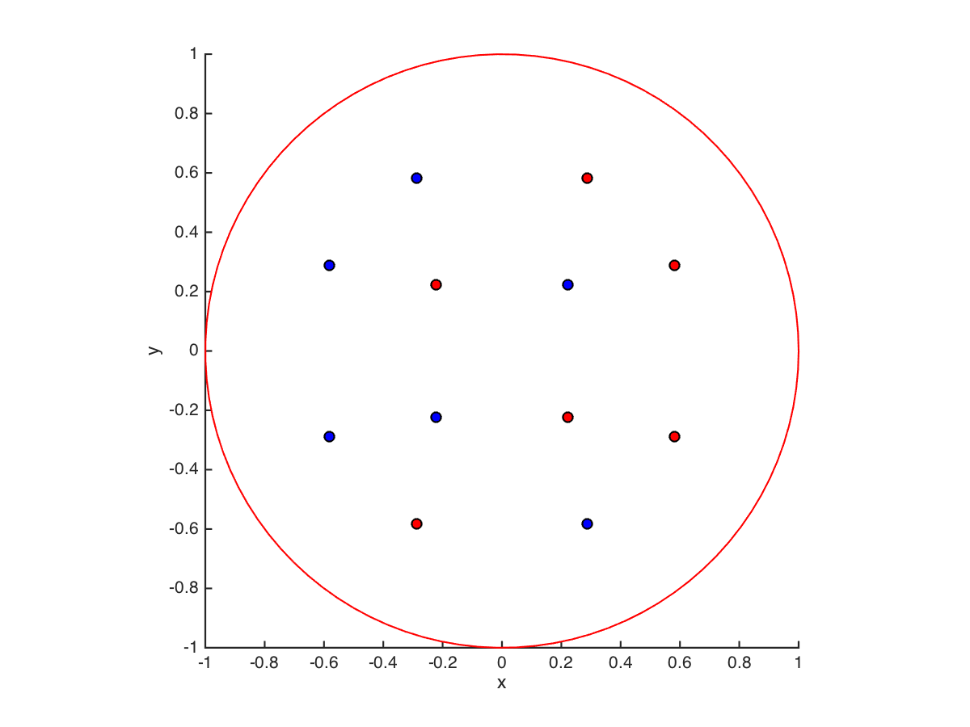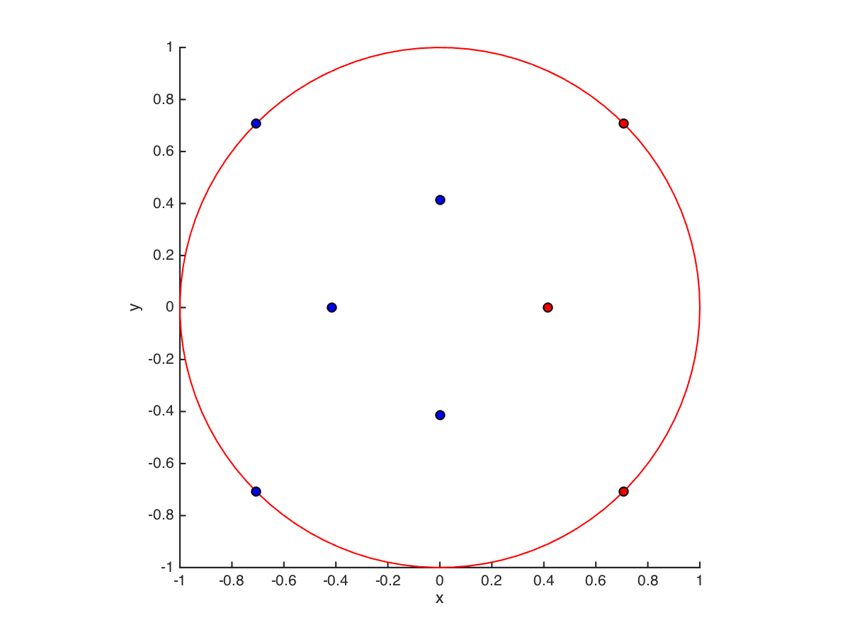

Copper component:

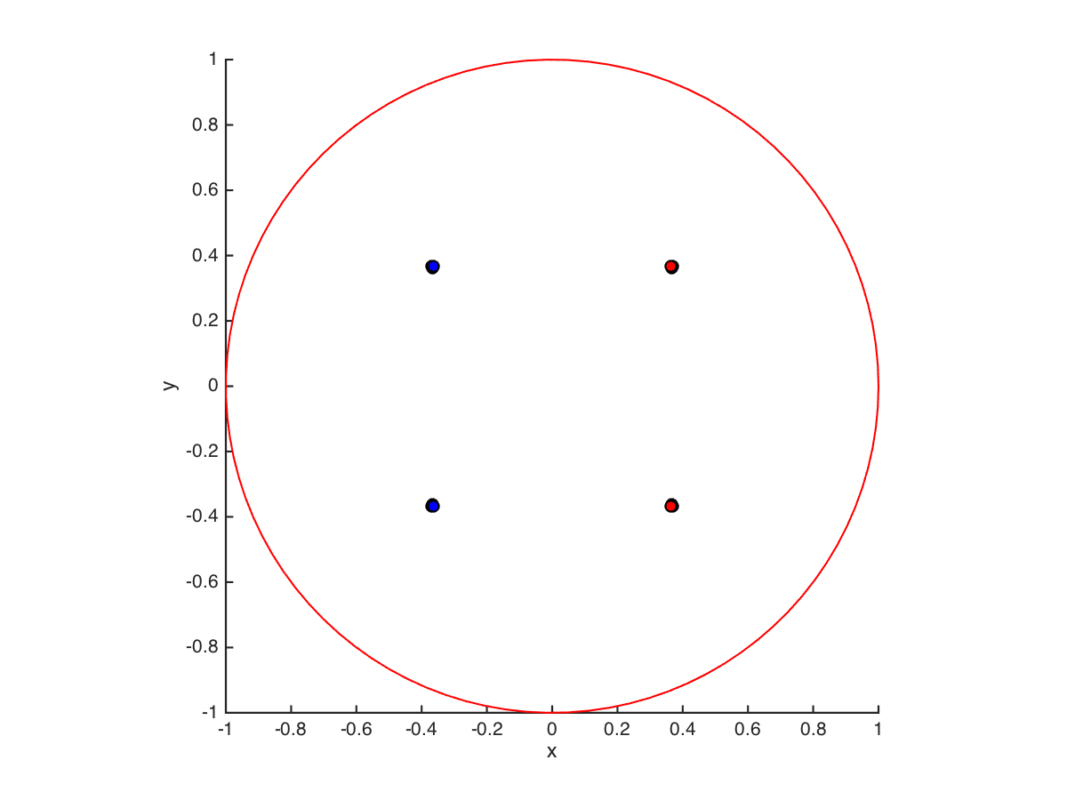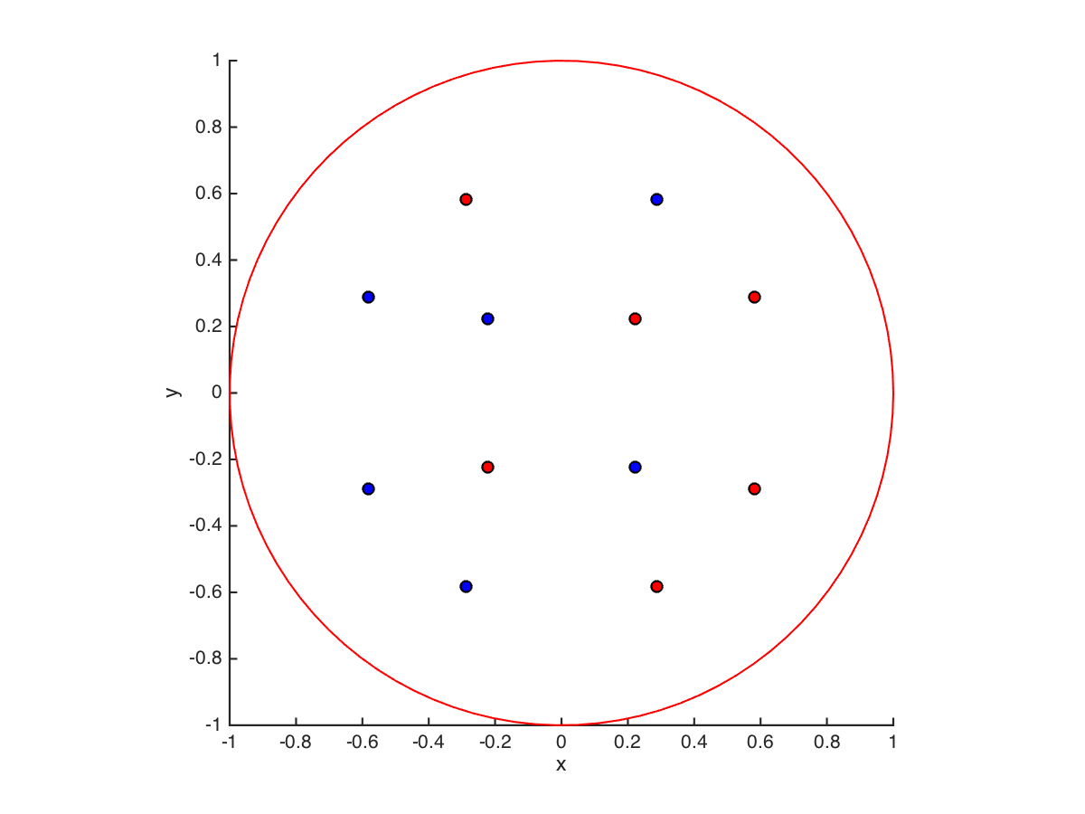

S component:

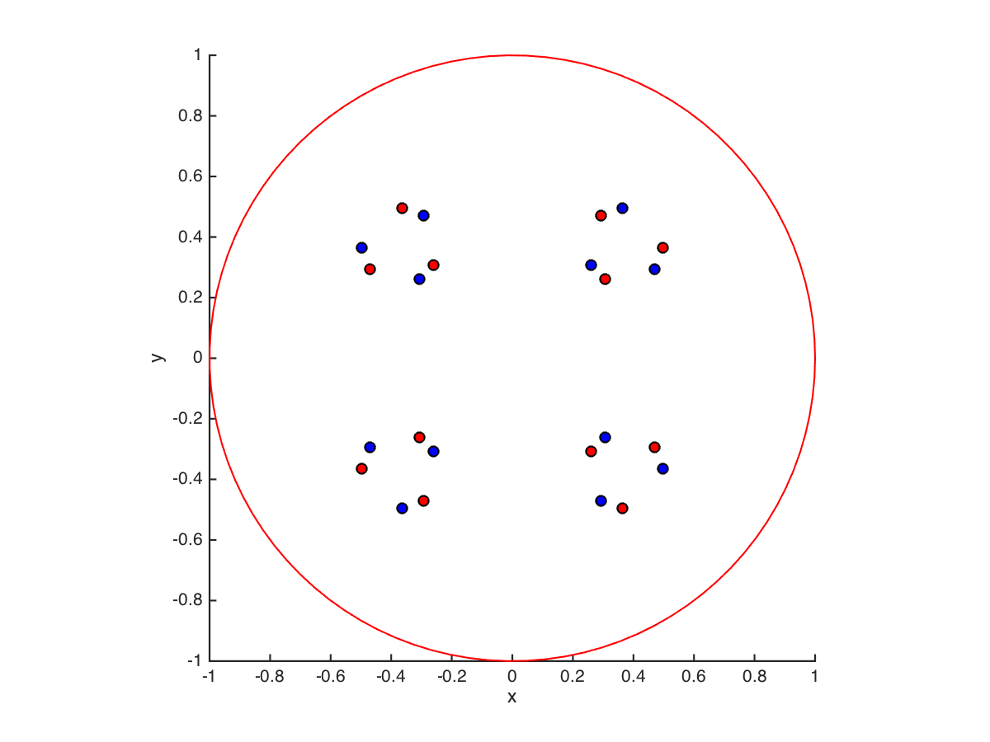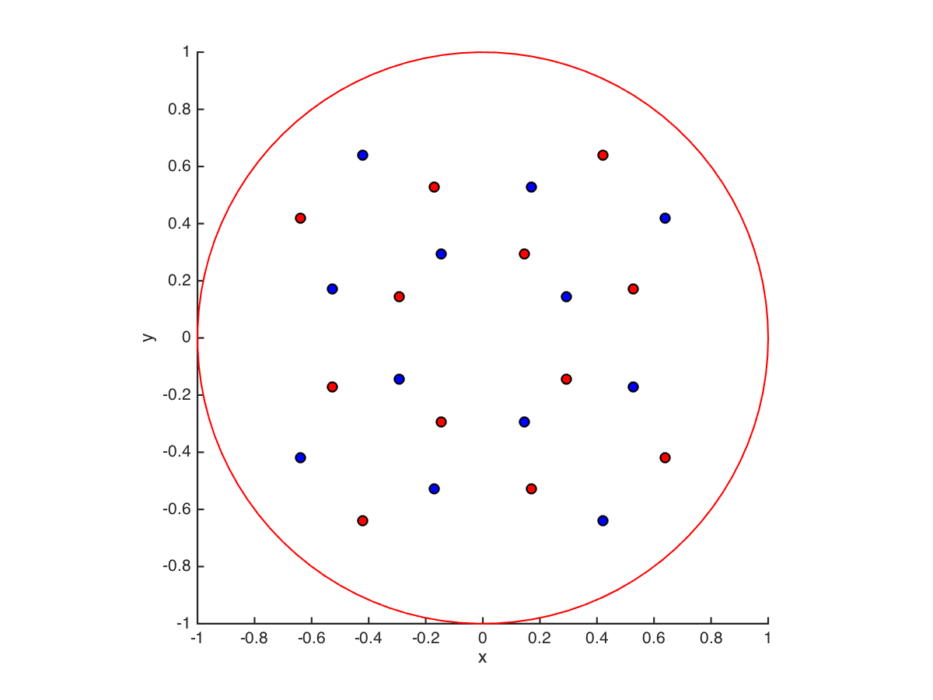

(b) No, sample symmetry makes no difference (or should not) ; however, it is interesting that applying only crystal symmetry to a sample pole and neglecting its negative yields only 12 poles in the upper hemisphere instead of 24, because there are only 24 rotational symmetry operators. The subtlety is that there should indeed be 24 (inverse) poles but the rotational symmetry is not enough. Adding sample symmetry happens to introduce 00-1 as well as 001, which results in the full 24.

(c) the required result is two triangles, each with 3 points;

(d) the (hkl) value corresponds to the position in the Z axis plot and the [uvw] value corresponds to the X axis plot position.

3. [20] Read the paper entitled “Stress hot spots in viscoplastic deformation of polycrystals” and answer the following questions. The document is available on Box as msms349293p16-proofs-ADR.pdf .

(a) What kind of plot is shown in Fig. 4 and why would a straight line correspond to a normal distribution?

(b) What is the “distance map” that is referred to in Fig. 8 and how is it calculated (pick any of the three variants depicted in the figure)?

(c) What does Fig. 10 tell us about the texture of the locations with high stress in the simulations that were carried out for this paper?

(d) Of the (von Mises) stress and strain-rate fields, which one shows the grain structure to some extent?

(e) Given that grain boundaries are understood to be barriers to slip (although no such provision was made in these simulations), it seems reasonable to expect high stresses next to grain boundaries. What was the counter-intuitive result with respect to stress levels adjacent to boundaries?

(a) This is a “probability plot” and the vertical axis is transformed (inverse normal function) such that a distribution whose cumulative density function corresponds to a normal distribution (bell curve) will result in a straight line.

(b) The distance map plots for each point how far away is the nearest grain boundary (or triple line, or quad junction).

(c) Figure 10 tells us the points with highest von Mises stress (based on a specific threshold value) correspond to 110 or 111 parallel to the stress axis. In more detail it shows that 111 is favored at lower threshold values (more points) and this shifts over to 110 at higher values (fewer points).

(d) The stress maps reveal the grain structure to a considerable extent whereas the strain-rate maps exhibit bands that are diagonal to the stress axis. Admittedly, the text in the paper had more to say about this and so it was possible to get confused. I should have pointed to a specific figure.

(e) The counter-intuitive result (at least to the first author!) was that not only were high stresses observed next to boundaries but so were low stresses, which is what Fig. 13 shows.

4. [20] Read the paper 1996-Acta-Baczynski-Jonas-Torsion-Textures.pdf (available in the Box folder), and answer the following questions.

(a) What does Fig. 15 tell us about the relative stability of different orientations?

(b) If you follow a horizontal line across the two upper sub-plots in Fig. 15 that passes through the points D1 and D2, what do you notice about the direction of change in orientation?

(c) If you arrive at point D1, say, and somehow the orientation is displaced slightly to the right (larger PHI), will you return to point D1, or something else? Comment, as best you can, on whether the points D1 (top right) and D2 (top left) represent fully stable orientations under torsional deformation.

(d) What sample symmetry can you see in Fig. 11?

(a) This is a map of orientation flow in Euler space. Wherever the arrows converge and/or become very small, these are locations of relative stability.

(b) The direction of change is everywhere the same.

(c) The arrows all point in the direction of larger PHI, so a slight displacement to the right will result in continuing orientation change in the same direction. This means that the points D1 and D2 are *not* fully stable end orientations but rather are metastable. Although not demanded by the question, figure 16 amplifies this point by computing the divergence at each point and showing that the net divergence is positive for D1 but negative for D2; therefore the latter is expected to be more stable. In fact, the situation is even more complicated because the boundary conditions applied axially affect the stability, i.e. fixed ends are different from free ends (i.e. no restriction on change in axial dimension).

(d) Monoclinic, with one diad (2-fold axis) in the center of the figure.

5. [10] Why is the spatial resolution in EBSD better at lower accelerating voltages (e.g., 10 kV) than at high values (e.g. 35 kV)?

Because the penetration depth and the size of the plume from which scattering occurs increases with accelerating voltage.

6. [10] Explain in your own words how the voting scheme is used in the indexing of diffraction patterns in EBSD to arrive at a “confidence index”. You are welcome to read papers outside the lecture notes.

The algorithm tries out different solutions (i.e. orientations, each one of which dictates what zone belongs to each peak in the Hough). Each solution is evaluated for how many triples of zones (peaks in the Hough) fit a set of inter-zonal angles for the given crystal structure. The best and the second best solution are used and the difference between the two, normalized by the best, provides the confidence index. It is calculated so that the largest difference yields the highest confidence value.